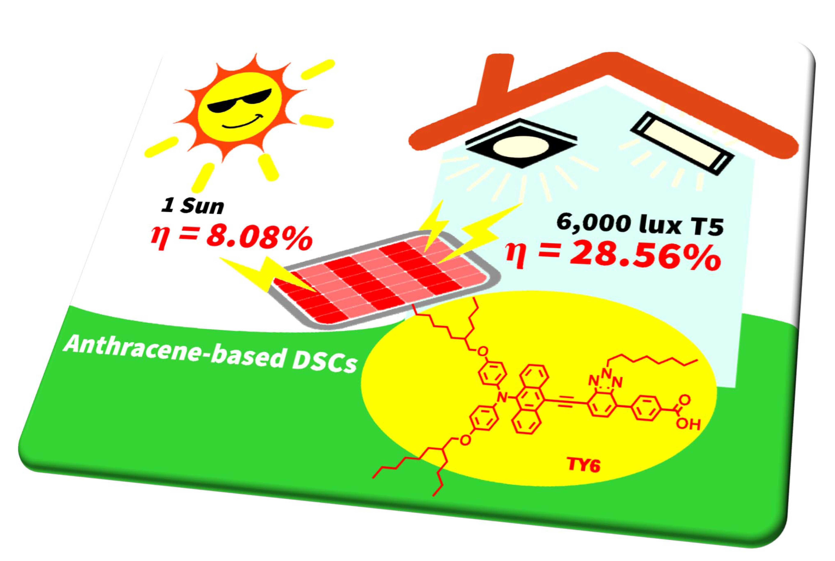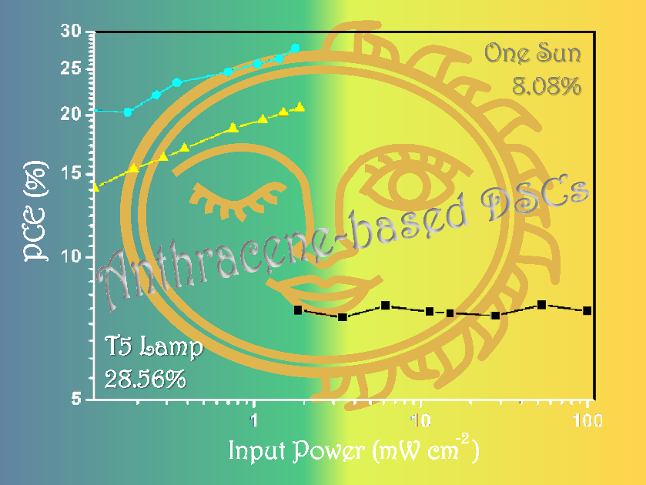

New Acetylene-Bridged 9,10-Conjugated Anthracene Sensitizers: Application in Outdoor and Indoor Dye-Sensitized Solar Cells

新型蒽取代光敏劑：具9,10-雙乙炔橋接之蒽基染料在染料敏化太陽能電池中的室內外應用

Adv. Energy Mater., 2017, 7, 1700032
DOI: 10.1002/aenm.201700032

Yogesh S. Tingare, Nguyễn So'n Vinh, Hsien-Hsin Chou, Yu-Chieh Liu, Yean-San Long, Teng-Chun Wu, Tzu-Chien Wei,* Chen-Yu Yeh*

In this report, a pivotal improvement in the performance of dye-sensitized solar cells (DSCs) has been achieved, thus taking it one step closer toward the commercialization. Judicious molecular design and synthesis of new metal free anthracene-based sensitizers resulted in DSCs exhibiting excellent sensitizing capability and cell performance. We obtained these dyes by using simple, convergent, and relatively short synthetic route, which are amenable to large-scale production. The substitution of alkoxy chains and electron deficient benzotriazole moiety in the π-conjugation indicates the importance of molecular design for tuning sensitizers to produce high efficiency DSSCs. Of the most important, the dye TY6, when tested under 1 Sun (AM 1.5G) illumination, is found to exhibit efficiency as high as 8.08%. When subjected to weak light illumination, sensitizer TY6 displayed outstanding efficiency of 20.72% and 28.56% under 6,000 lux of commercially available LED and T5 fluorescent light sources, respectively. The 28.56% efficiency under T5 irradiance is highest among any dyes reported till date. Such extraordinary performance is due to its high V_{OC} over 0.6 V even under 300 lux dim light and matching of its UV–vis profile to that of the T5 light source.

在本研究中，染料敏化太陽能電池（DSC）的研究有了極關鍵的突破，使染敏電池之商業化應用又邁進了一大步。藉由明智的分子設計，我們合成出全新不含金屬的蒽基光敏化劑，並證實其擁有優異的光敏化能力和染敏電池性能。我們透過較簡單、一致和較少步驟的設計來合成這些染料，使其有利於未來之大規模量產。同時，此系列高效率染料結構中所具有之π-共軛中的烷氧基和苯併三唑缺電子基團，也證實與染敏電池的高效率息息相關，並凸顯出分子設計的重要性。最重要的是，當在1 Sun（AM 1.5G）之光照條件下測試時，染料TY6的光電轉換效率高達8.08％。而於弱光照射條件下，在6,000 lux的市售LED燈和T5螢光燈光源下，光敏化劑TY6分別顯示出20.72％和28.56％的卓越轉換效率。此28.56％的超高效率在當時所見之文獻報導中，為所有染料最高。這種非凡的性能歸功於TY6染料與T5光源極匹配的光吸收範圍、與特殊的高開環電壓（V_{OC}），在即便如300 lux之昏暗光線下，TY6仍可輸出高達0.6V的電壓。

