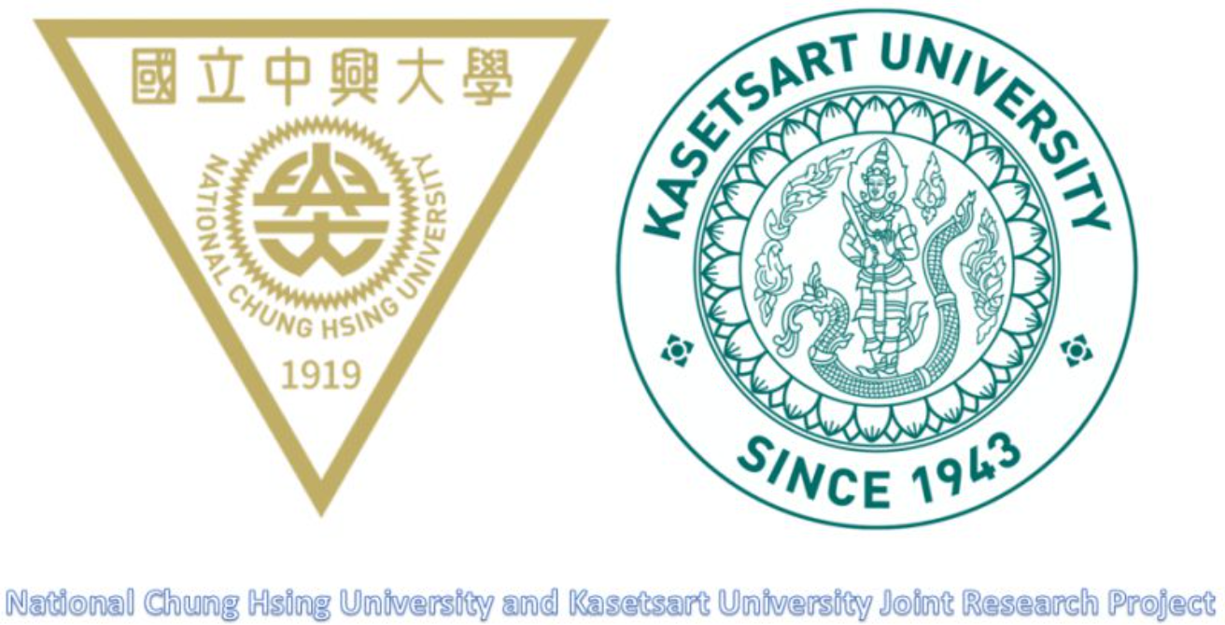
Thailand-Taiwan Bilateral Symposium on Science, Agriculture and Technology
臺泰雙邊合作成果發表會暨研討會

Date: 18th Nov. 2021
Place: Room101, Room103, Electrical Engineering & Computer Science Building, NCHU

Jointly Organized by,
i- Center for Advanced Science and Technology, NCHU (Taiwan)
Innovation and Development Center of Sustainable Agriculture, National Chung Hsing University (Taiwan)
and
Faculty of Science at Sriracha, Kasetsart University (Thailand)
Faculty of Agriculture, Kasetsart University (Thailand)
Faculty of Engineering, Kasetsart University (Thailand)

Time  (TH) | Time  (TW) | 18th Nov.
08:00-08:10 | 09:00-09:10 | Registration  Location: Room 101
08:10-08:30 | 09:10-09:30 | Opening Ceremony  Chongrak Wachrinrat Ph.D.  President, KU  Chang-Hsien Yang Ph.D.  Vice President, NCHU
08:30-09:00 | 09:30-10:00 | Keynote Speech 1  Assist. Prof. Pattarawadee Sumthong Nakmee  Dean of Faculty of Science at Sriracha, KU  TOPIC: Phytochemical Constituents and Anti-cancer Activities from Peltophorum Dasyrachis and Dialium Cochinchinense Bark Extracts for Traditional Jellyfish Pickle.
09:00-09:30 | 10:00-10:30 | Keynote Speech 2  Prof. Hsin-I Chiang  Department of Animal Science, NCHU  TOPIC: Nutrition validation of straws from mutant brittle rice varieties as feed roughages in Holstein cows
 |  | Workshop 1: Agriculture  Chair: Prof. Hsin-I Chiang (江信毅)  Location: Room 101 | Workshop 2: Engineering  Chair: Prof. Jau Huai Lu(盧昭暉)  Location: Room 103
09:30-10:00 | 10:30-11:00 | P-01  Dr. Chalathon Choocharoen  Agricultural Extension and Communication Department, KU  TOPIC: Social network analysis for agricultural trading: An investigation of the actors along agricultural commodities supply chain between Taipei and Bangkok. | P-08  Assoc. Prof. Tongsai Jamnongkan  Department of fundamental Science and Physical Education, KU  TOPIC: Development the antimicrobial of ZnO electrospun fiber for 3D printing application.
10:00-10:20 | 11:00-11:20 | Tea Break
10:20-10:50 | 11:20-11:50 | P-02  Prof. Tzong-Ru Lee  Marketing Department, NCHU  TOPIC: Understanding consumer purchasing decision on choosing tea shop in Taiwan and Thailand before and during COVID-19 pandemic. | P-09  Assoc. Prof. Penjit Srinophakun  Chemical Engineering Department, KU  TOPIC: Life Cycle Assessment (LCA) and Cost Estimation Analysis of PVA and Lignin Mulching film.
10:50-11:20 | 11:50-12:20 | P-03  Assoc. Prof. Penjit Srinophakun  Department of Chemical Engineering, KU  TOPIC: Active Compound Production from Large Scale Koji Fermentation. | P-10  Prof. Hui-Min Wang  Graduate Institute of Biomedical Engineering, NCHU  TOPIC: Antioxidant and anticancer effects of Cordyceps sinensis extracts on metastatic melanoma.
11:20-12:00 | 12:20-13:00 | Lunch
 |  | Workshop 3: Agriculture  Chair: Prof. Yao-Tung Lin (林耀東)  Location: Room 101 | Workshop 4: Engineering  Chair: Prof. Hui-Min Wang (王惠民) Location: Room 103
12:00-12:30 | 13:00-13:30 | P-04  Assist. Prof. Kok-Boom Neoh  Department of Entomology, NCHU  TOPIC: Effects of piperonyl butoxide synergism and cuticular thickening on the contact irritancy response of field Aedes aegypti (Diptera: Culicidae) to deltamethrin. | P-11  Prof. Heng-Jui Liu  Department of Materials Science and Engineering, NCHU  TOPIC: New Opportunities toward efficient water splitting - Perovskite oxide catalysts.
12:30-1300 | 13:30-14:00 | P-05  Prof. Theeraphap Chareonviriyaphap  Department of Entomology, KU  TOPIC: Exploring a novel method in dengue control. | P-12  Prof. Ratiporn Munprom  Department of Materials Engineering, KU  TOPIC: Fabrication and characterization of nanostructure WO3 photoanode for photoelectrochemical water splitting.
13:00-13:30 | 14:00-14:30 | P-06  Kesinee Iamsaard  Department of Soil and Environmental Sciences, NCHU  TOPIC: Agri-Biodegradable Mulch Films Driven from Agricultural Wastes on Sustainable Agriculture System. | P-13  Prof. Kun-Yi Lin  Environmental Engineering Department, NCHU  TOPIC: Ultrafine cobalt nanoparticle-embedded leaf-like hollow N-doped carbon as an enhanced catalyst for activating monopersulfate to degrade phenol.
13:30-14:00 | 14:30-15:00 | P-07  Dr. K.Teepalak Rangubhet  Department of Animal Science, KU  TOPIC: Evaluation of nutrient utilization and rumen digestibility of Taiwan brittle rice straw. | P-14  Assoc. Prof. Sanya irivithayapakorn  Environmental Engineering Department, KU  TOPIC: Efficiency and Selectivity of Photocatalytic Nitrate Reduction Process under Different Initial Nitrate Concentrations and Catalyst Dosages.
14:00-14:20 | 15:00-15:20 | Tea Break
 |  | Workshop 5: Agriculture  Chair: Prof. Kok-Boom Neoh(梁國汶)  Location: Room 101 | Workshop 6: Engineering  Chair: Prof. Jeng-Liang Han (韓政良)  Location: Room 103
14:20-14:50 | 15:20-15:50 | I-01  Assoc. Prof. Soontree Khuntong  Department of Natural Resources and Environment, KU  TOPIC: Lipase digestion by indigenous bacteria for used frying oil-based biodiesel synthesis | II-01  Assist. Prof. P.Pungboon Pansila,  Head of Department of Basic Science and Physical Education, KU  TOPIC: Low temperature atomic layer deposition of oxide and nitride thin films: computation and experimentation.
14:50-15:20 | 15:50-16:20 | I-02  Assist. Prof. Saroch Kaewmanee  Department of Animal Science, KU  TOPIC: Innovative Protein Sources: Possibilities for Future Sustainable Agriculture and Related Purposes | II-02  Prof. Attasak Jaree  Department of Chemical Engineering, KU  TOPIC: Production of 5-Hydroxymethyl Furfural from Fructose and Glucose in a Fixed-Bed Reactor
15:20-15:40 | 16:20-16:40 | I-03  Assoc. Prof. Jamroen Thiengtham  Department of Animal Science, KU  TOPIC: Laying hens in enriched cages: Improving their welfare status | II-03  Assist. Prof. Gasidit Panomsuwan  Department of Materials Engineering, KU  TOPIC: Plasma-Assisted Synthesis of Nitrogen-Doped Carbons as Electrocatalysts for Oxygen
15:40-16:10 | 16:40-17:10 | I-04  Dr. Nittaya Chookoh  Department of Horticulture, KU  TOPIC: Effect of different forcing duration at 20°C on flowering acceleration in tolumnia orchids  Reduction Reaction | II-04  Associate. Prof. Pongsak Noophan  Department of Environmental Engineering, KU  TOPIC: Effect of COD:N Ratio on Biological Nitrogen Removal using Full-scale Step-feed in Municipal Wastewater Treatment Plants (Case Study: Taiwan and Bangkok)
16:10-16:20 | 17:10-17:20 | Concluding Remarks  Jenn-Ming SONG Ph.D.  Dean of the Office of Research and Development, NCHU

