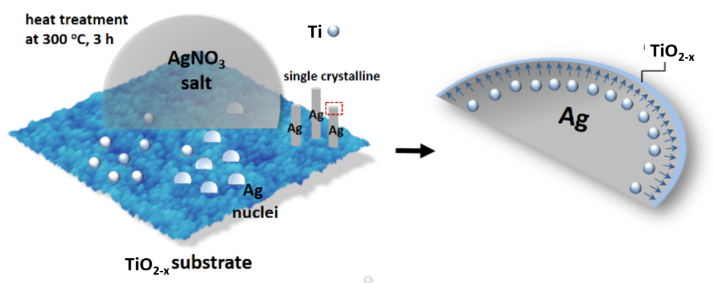
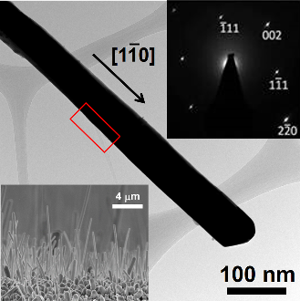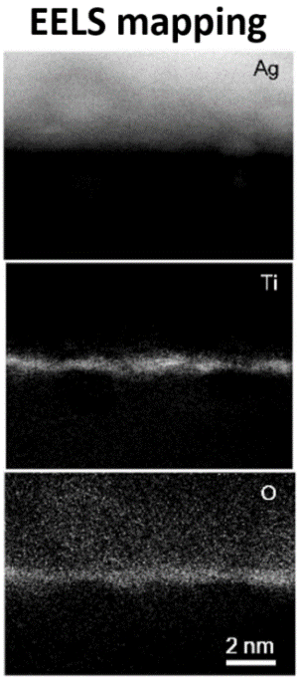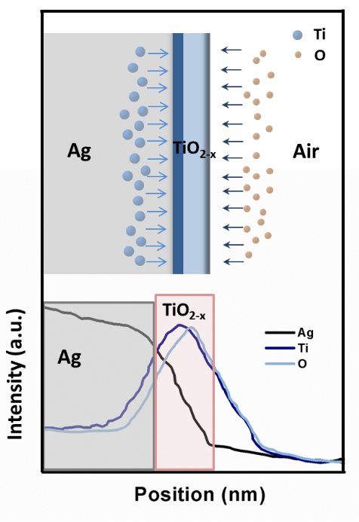

Spontaneous growth of ultra-thin titanium oxides shell on Ag nanowires: an electron energy loss spectroscope observation
於銀奈米線表面之超薄二氧化鈦殼層自發性成長：EELS光譜觀察

Chem. Commun., 52(2015)16825

DOI: 10.1039/c5cc06782k

Chi-Hang Tsai, Shih-Yun Chen*, Jenn-Ming Song* and Alexandre Gloter

The performance of nanowires is often limited. One of the important solving methods is to synthesize composite nanowires such as core-shell nanowires to enhance functionality and usability. With respect to the Ag-TiO₂ core-shell nanowires, the silver nanowires have unique properties of high surface plasmon resonance as well as good electrical conductivity, while TiO₂ is an ideal material as photocatalysts. In the absence of oxide precursors, templates, inoculants and surfactants, Ag nanowires with a spontaneous ultra-thin TiO₂ shell (~0.5 nm) can be vertically grown on TiO₂ substrate. STEM/EELS results demonstrate that this oxygen-deficient TiO₂ layer is formed through the oxidation of Ti which is released from the substrate and segregated to the nanowire surface simultaneously with crystal growth of the nanowires.

為提升奈米線的表現，以核殼結構加強其功能與使用性為一重要做法，以Ag-TiO₂核殼奈米線的組合為例，銀具有良好表面電漿共振與極佳電性，TiO₂殼層則為光催媒。本研究在不使用氧化物前趨物、模板、成核劑與表面活性劑情況下，於TiO₂基板上成功合成表面自發形成~0.5 nm厚殼層之直立Ag@TiO₂核殼奈米線。STEM/EELS影像顯示此具高氧空缺之TiO₂殼層為基板釋出的鈦於銀單晶成長過程中同步排出至表面氧化而成。

